# Business Model for Ecommerce

## Introduction to Business Model

A business model is the methods of doing business by which a company can sustain itself, that is, generate revenue. The business model spells out how a company makes money by specifying where it is positioned in the value chain.

Some models are quite simple. A company produces goods or services and sells it to customers. If all goes well, the revenues from sales exceed the cost of operation and the company realizes profit. Other models can be more complex. Radio and television broadcasting is a good example. The broadcaster is part of a complex network of distributors, content creators, advertisers, and listeners or viewers. Who makes money and how much, It is not always clear at the outset. The bottom line depends on many competing factors.

For our understanding, e-commerce can be defined as any form of business transaction in which the parties interact electronically.' A transaction in an electronic market represents a number of interactions between parties. For instance, it could involve several trading steps, such as marketing, ordering, payment, and support for delivery. An electronic market allows the participating sellers and buyers to exchange goods and services with the aid of information technology. Electronic markets have three main functions such as:

1. matching buyers and sellers,
2. facilitating commercial transactions, and
3. providing legal infrastructure.

Information technology permeates all the three functions and also helps to increase market efficiency and reduce transaction costs.

The interaction between participants is supported by electronic trade processes that are basically search, valuation, payment and settlement, logistics, and authentication, as shown in Figure. The Internet and the World Wide Web allow companies to efficiently implement these key trading processes. For instance, many search services and brokers are available to help buyers find information, products, and merchants in electronic markets.

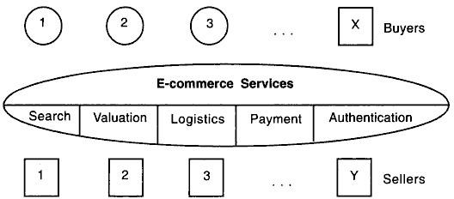

E-commerce can be formally defined as technology-mediated exchanges between parties (individuals, organizations, or both) as well as the electronically-based intra- or inter- organizational activities that facilitate such exchanges. It is global. It favors intangible things—ideas, information, and relationships. And it is intensely interlinked. These three attributes produce a new type of marketplace and society.

A company's business model is the way in which it conducts business in order to generate revenue. In the new economy, companies are creating new business models and reinventing old models. Reading the literature, we find business models categorized in different ways. Presently, there is no single, comprehensive and cogent taxonomy of Web business models that one can point to.

**2.1 E-business model based on relationship of transaction parties:**

## Business-to- consumer,

The B2C model involves transactions between business organizations and consumers. It applies to any business organization that sells its products or services to consumers over the Internet. These sites display product information in an online catalog and store it in a database. The B2C model also includes services online banking, travel services, and health information and many more as shown in figure below.

Consumers are increasingly going online to shop for and purchase products, arrange financing, arrange shipment or take delivery of digital products such as software, and get service after the sale. B2C e-business includes retail sales, often called e-retail (or e-tail), and other online purchases such as airline tickets, entertainment venue tickets, hotel rooms, and shares of stock.

Some B2C e-businesses provide high-value content to consumers for a subscription fee. Examples of e-business following this subscription model include the Wall Street Journal (financial news and articles), Consumer Reports (product reviews and evaluations), and [ediels.com](http://erliels.com/) (nutritional counseling).

B2C e-business models include virtual malls, which are websites that host many online merchants. Virtual malls typically charge setup, listing, or transaction fees to online merchants, and may include transaction handling services and marketing options. Examples of virtual malls include excite.com, choice mall, [women.com](http://women.com/), [networkweb.com](http://networkweb.com/), amazon.com, Zshops.com, and [yahoo.com.](http://yahoo.com/)

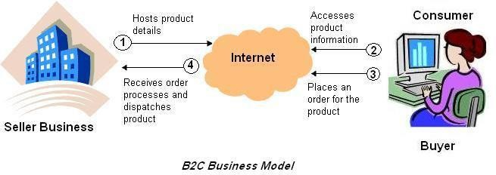

E-tailors that offer traditional or Web-specific products or services only over the Internet are sometimes called virtual merchants, and provide another variation on the B2C model. Examples of virtual merchants include [amazon.com](http://amazon.com/) (books. electronics, toys, and music), [eToys.com](http://etoys.com/) (children's books and toys), and [ashford.com](http://ashford.com/) (personal accessories).

Some businesses supplement a successful traditional mail-order business with an online shopping site, or move completely to Web-based ordering. These businesses are sometimes called catalogue merchants. Examples include [avan.com](http://avan.com/) (cosmetics and fragrances), chefs (cookware and kitchen accessories), Omaha Steaks (premium steaks, meats, and other gourmet food), and Harry and David (gourmet food gifts).

Many people were very excited about the use of B2C on the Internet, because this new communication medium allowed businesses and consumers to get connected in entirely new ways. The opportunities and the challenges posed by the B2C e-commerce are enormous. A large amount of investment has gone into this and many sites have either come up or are coming up daily to tap this growing market.

Some of the reasons why one should opt for B2C are:

* + - 1. **Inexpensive costs**, big opportunities. Once on the Internet, opportunities are immense as companies can market their products to the whole world without much additional cost.
      2. **Globalization.** Even being in a small company, the Web can make you appear to be a big player which simply means that the playing field has been leveled by e- business. The Internet is accessed by: millions of people around the world, and definitely, they are all potential customers.
      3. **Reduced operational costs**. Selling through the Web means cutting down on paper costs, customer support costs, advertising costs, and order processing costs.
      4. **Customer convenience.** Searchable content, shopping carts. Promotions and interactive and user-friendly interfaces facilitate customer convenience. Thus, generating more business. Customers can also see order status, delivery status, and get their receipts online.
      5. **Knowledge management.** Through database systems and information management, you can find out who visited your site, and how to create, better value for customers.

## Processes in B2C (How Does B2C Work?)

B2C e-commerce is more than just an online store. It really is about managing the entire process, but just using technology as a tool for order processing and customer support.

Following figure depicts the processes in B2C.

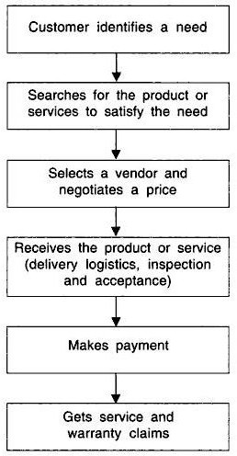

The B2C process is now explained in greater details:

1. **Visiting the virtual mall**. The customer visits the mall by browsing the online catalogue—a very organized manner of displaying products and their related information such as price, description, and availability. Finding the right product becomes easy by using a keyword search engine. Virtual malls may include a basic to an advanced search engine, product rating system, content management, customer support systems, bulletin boards, newsletters and other components which make shopping convenient for shoppers.
2. **Customer registers**. The customer has to register to become part of the site's shopper registry. This allows the customer to avail of the shop's complete services. The customer becomes a part of the company's growing database and can use the same for knowledge management and data mining.
3. **Customer buys products**. Through a shopping cart system, order details, shipping charges, taxes, additional charges and price totals are presented in an organized manner. The customer can even change the quantity of a certain product. Virtual malls have a very comprehensive shopping system, complete with check-out forms.
4. **Merchant processes the order**. The merchant then processes the order that is received from the previous stage and fills up the necessary forms.
5. **Credit card is processed**. The credit card of the customer is authenticated through a payment gateway or a bank. Other payment methods can be used as well, such as debit cards, prepaid cards, or bank-to-bank transfers.
6. **Operations management**. When the order is passed on to the logistics people, the traditional business operations will still be used. Things like inventory management. total quality management, warehousing, optimization and project management should still be incorporated even though it is an e-business. Getting the product to the customer is still the most important aspect of e-commerce.
7. **Shipment and delivery**. The product is then shipped to the customer. The customer can track the order/delivery as virtual malls have a delivery tracking module on the website which allows a customer to check the status of a particular order.
8. **Customer receives**. The product is received by the customer, and is verified. The system should then tell the firm that the order has been fulfilled.
9. **After-sales service**. After the sale has been made, the firm has to make sure that it maintains a good relationship with its customers. This is done through customer relationship management or CRM.

The example of the [www.amazon.com](http://www.amazon.com/) site also involves the B2C model in which the consumer searches for a book on their site and places an order, if required. This implies that a complete business solution might be an integration solution of more than one business model. For example, [www.amazon.com](http://www.amazon.com/) includes the B2B model in which the publishers transact with Amazon and the B2C model in which an individual consumer transact with the business organization. The B2C model of e-commerce is more prone to the security threats because individual consumers provide their credit card and personal information n the site of a business organization. In addition, the consumer might doubt that his information is secured and used effectively by the business organization. This is the main reason why the B2C model is not very widely accepted. Therefore, it becomes very essential for the business organizations to provide robust security mechanisms that can guarantee a consumer for securing his/her information.

### Usage of B2C E-Commerce Model

1. **Online Retail Stores:**
   * Companies like Amazon, Walmart, and eBay operate B2C e-commerce platforms where consumers can purchase products directly.
2. **Digital Goods and Services:**
   * Companies like Netflix and Spotify provide digital content such as movies, music, and subscriptions directly to consumers.
3. **Direct-to-Consumer (D2C) Brands:**
   * Brands like Warby Parker and Dollar Shave Club bypass traditional retail channels to sell directly to consumers online.
4. **Online Marketplaces:**
   * Platforms like Etsy and Alibaba allow individual sellers to reach consumers directly.
5. **Service-Based Businesses:**
   * Services such as online travel booking (e.g., Expedia) and food delivery (e.g., Uber Eats) operate on a B2C model.

### Advantages of B2C E-Commerce Model

1. **Global Reach:**
   * B2C e-commerce allows businesses to reach customers worldwide, expanding their market beyond geographical limitations.
2. **Lower Operating Costs:**
   * Operating an online store is generally less expensive than maintaining a physical retail space, reducing overhead costs.
3. **Convenience:**
   * Consumers can shop from anywhere at any time, increasing accessibility and convenience.
4. **Personalization:**
   * Businesses can use data analytics to offer personalized shopping experiences, such as product recommendations and targeted advertising.
5. **Direct Feedback:**
   * Businesses can gather direct feedback from customers through reviews and ratings, enabling them to improve their products and services.
6. **Speed and Efficiency:**
   * Transactions can be completed quickly, and automated processes reduce the time and effort required for operations.
7. **Scalability:**
   * E-commerce platforms can easily scale to handle increased traffic and sales volume, especially during peak periods.
8. **Data Collection and Analysis:**
   * Businesses can collect valuable data on consumer behavior, preferences, and purchasing patterns, aiding in decision-making and marketing strategies.

### Disadvantages of B2C E-Commerce Model

1. **Intense Competition:**
   * The global nature of e-commerce means businesses face intense competition, often leading to price wars and reduced profit margins.
2. **Security Concerns:**
   * Consumers are increasingly concerned about the security of their personal and financial information, requiring businesses to invest in robust cybersecurity measures.
3. **Dependency on Technology:**
   * Technical issues such as website downtime, payment processing failures, or cyber-attacks can disrupt business operations and damage customer trust.
4. **Logistics and Delivery Challenges:**
   * Managing logistics, shipping, and delivery can be complex and costly, especially for businesses that sell physical products.
5. **Lack of Personal Interaction:**
   * The absence of face-to-face interaction can make it difficult for businesses to build strong relationships with customers, impacting brand loyalty.
6. **Customer Trust and Privacy:**
   * Building and maintaining customer trust in an online environment can be challenging, especially with concerns over data privacy and fraudulent activities.
7. **Returns and Refunds:**
   * Handling returns and refunds can be more complex and costly for online transactions compared to in-store purchases.
8. **Market Saturation:**
   * As more businesses enter the online space, markets can become saturated, making it harder for new entrants to gain visibility and attract customers

## Business-to-Business,

The B2B model involves electronic transactions for ordering, purchasing, as well as other administrative tasks between business houses. It includes trading goods, such as business subscriptions, professional services, manufacturing, and wholesale dealings. Sometimes in the B2B model, business may exist between virtual companies, neither of which may have any physical existence. In such cases, business is conducted only through the Internet.

Let us look at the example of [www.amazon.com.](http://www.amazon.com/) As you know, [www.amazon.com](http://www.amazon.com/) is an online bookstore that sells books from various publishers including Wrox, O’Reilly, Premier Press, and so on. In this case, the publishers have the option of either developing their own site or displaying their books on the Amazon site (www.amazon.com), or both. The publishers mainly choose to display their books on [www.amazon.com](http://www.amazon.com/) at it gives them a larger audience. Now, to do this, the publishers need to transact with Amazon, involving business houses on both the ends, is the B2B model as shown in figure below.

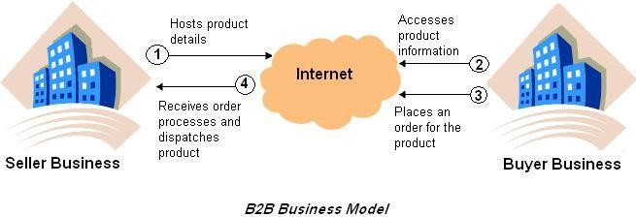

Thus, B2B is that model of e-commerce whereby a company conducts its trading and other commercial activity through the Internet and the customer is another business itself. This essentially means commercial activity between companies through the Internet as a medium.

This is supposed to be a huge opportunity area on the Web. Companies have by and large computerized all the operations worldwide and now they need to go into the next stage by linking their customers and vendors. This is done by supply chain software, which is an integral part of your ERP application. Companies need to set up a backbone of B2B applications, which will support the customer requirements on the Web. Many B2B sites are company and industry specific, catering to a community of users, or are a combination of forward and backward integration. Companies have achieved huge savings in distribution- related costs due to their B2B applications.

## Major Advantages of B2B

* + - 1. **Direct interaction with customers**. This is the greatest advantage of e-business.
      2. **Focused sales promotion**. This information gives authentic data about the likes, dislikes and preferences of clients and thus helps the company bring out focused sales promotion drives which arc aimed at the right audience.
      3. **Building customer loyalty**. It has been observed that online customers can be more loyal than other customers if they are made to feel special and their distinct identity is recognized and their concerns about privacy are respected. It has also been found that once the customers develop a binding relationship with a site and its product, they do not like to shift loyalties to another site or product.
      4. **Scalability**. This means that the Web is open and offers round-the-clock access. This provides an access never known before, to the customer. This access is across locations and time zones. Thus a company is able to handle many more customers on a much wider geographical spread if it uses an e-business model. The company can set up a generic parent site for all locations and make regional domains to suit such requirements. Microsoft is using this model very successfully.
      5. **Savings in distribution costs**. A company can make huge savings in distribution, logistical and after-sales support costs by using e-business models. Typical examples are of computer companies, airlines, and telecom companies.

## Processes for Business-to-Business Transactions and Models

B2B interactions involve much more complexity than B2C. For instance, typical B2B transactions include, among others, the following steps:

1. Review catalogues,
2. Identify specifications.
3. Define requirements,
4. Post request for proposals (REP).
5. Review vendor reputation.
6. Select vendor.
7. Fill out purchase orders (PO).
8. Send PO to vendor,
9. Prepare invoice,
10. Make payment,
11. Arrange shipment, and
12. Organize product inspection and reception

Due to the large number of transactions involved, business-to-business operations can be too risky if e-business sites cannot guarantee adequate quality of service in terms of performance, availability and security.

### Usage of B2B E-Commerce Model

1. **Wholesale and Distribution:**
   * Companies such as Alibaba, Amazon Business, and Grainger provide platforms where businesses can purchase products in bulk for resale or production.
2. **Supply Chain Management:**
   * Businesses use B2B e-commerce platforms to manage and streamline procurement processes, order supplies, and manage inventory.
3. **Manufacturing:**
   * Manufacturers sell raw materials, components, or finished products to other businesses, often using specialized B2B platforms.
4. **Service Providers:**
   * Companies offering services like IT support, marketing, consulting, and logistics often operate under a B2B e-commerce model, providing these services to other businesses.
5. **E-Procurement Systems:**
   * Large corporations often use e-procurement platforms to automate the purchasing of goods and services from approved suppliers.
6. **B2B Marketplaces:**
   * Platforms like ThomasNet and Global Sources act as intermediaries, connecting buyers with suppliers across various industries.
7. **Software as a Service (SaaS):**
   * Businesses offering SaaS products (e.g., Salesforce, Microsoft 365) typically operate on a B2B model, selling software subscriptions to other businesses.

### Advantages of B2B E-Commerce Model

1. **Larger Order Volumes:**
   * B2B transactions often involve bulk orders, leading to higher revenue per transaction compared to B2C sales.
2. **Long-Term Relationships:**
   * B2B e-commerce often leads to long-term partnerships between businesses, with repeat orders and ongoing contracts providing stable revenue streams.
3. **Efficient Supply Chain Management:**
   * B2B platforms can streamline the procurement process, reducing the time and cost associated with sourcing, ordering, and managing supplies.
4. **Customization and Flexibility:**
   * B2B e-commerce platforms often offer customizable solutions, including pricing, payment terms, and product specifications, tailored to the needs of each business client.
5. **Reduced Operational Costs:**
   * Automating business processes like order management, invoicing, and customer service can significantly reduce operational costs.
6. **Global Reach:**
   * B2B e-commerce enables businesses to expand their market globally, reaching new clients and suppliers without the need for physical presence.
7. **Improved Data Management:**
   * B2B platforms allow businesses to collect and analyze data on purchasing behaviors, inventory levels, and market trends, leading to better decision-making.
8. **Enhanced Collaboration:**
   * B2B platforms often provide tools for better collaboration between businesses, including shared supply chain visibility, real-time communication, and project management features.
9. **Scalability:**
   * B2B e-commerce platforms are often designed to handle the complexities of growing businesses, making it easier to scale operations.

### Disadvantages of B2B E-Commerce Model

1. **Complex Sales Processes:**
   * B2B transactions often involve multiple decision-makers, longer sales cycles, and complex negotiation processes, making the sales process more time-consuming and resource-intensive.
2. **High Initial Investment:**
   * Setting up a B2B e-commerce platform, especially with customized features and integration with existing systems, requires significant upfront investment in technology and training.
3. **Dependence on Relationships:**
   * B2B transactions often rely heavily on strong relationships and trust between businesses, which can take time to establish and maintain.
4. **Security Concerns:**
   * Handling large transactions and sensitive business data online necessitates robust cybersecurity measures, which can be costly and complex to implement.
5. **Customization Challenges:**
   * While customization is an advantage, it also presents challenges in terms of managing and maintaining customized orders, pricing, and services.
6. **Market Saturation:**
   * In highly competitive industries, the B2B market can become saturated, making it difficult for new entrants to gain a foothold.
7. **Complex Integration Requirements:**
   * B2B e-commerce platforms often need to be integrated with other business systems (e.g., ERP, CRM), which can be complex and costly.
8. **Limited Target Audience:**
   * Unlike B2C, where the potential customer base is vast, B2B e-commerce targets a smaller, more specific audience, which can limit growth opportunities.
9. **Logistics and Supply Chain Challenges:**
   * Managing logistics, especially for large, complex orders, can be challenging, requiring sophisticated systems and processes to ensure timely delivery.

## Consumer-to-Consumer,

The C2C model involves transaction between consumers. Here, a consumer sells directly to another consumer. eBay and [www.bazee.com](http://www.bazee.com/) are common examples of online auction Web sites that provide a consumer to advertise and sell their products online to another consumer. However, it is essential that both the seller and the buyer must register with the auction site. While the seller needs to pay a fixed fee to the online auction house to sell their products, the buyer can bid without paying any fee. The site brings the buyer and seller together to conduct deals as shown in figure below.

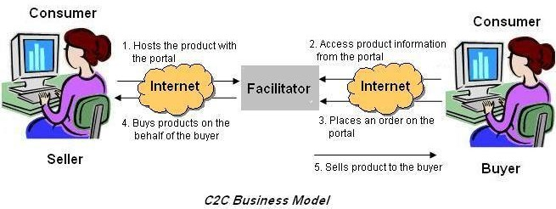

Let us now look at the previous figure with respect to eBay. When a customer plans to sell his products to other customers on the Web site of eBay, he first needs to interact with an eBay site, which in this case acts as a facilitator of the overall transaction. Then, the seller can host his product on [www.ebay.com,](http://www.ebay.com/) which in turn charges him for this. Any buyer can now browse the site of eBay to search for the product he interested in. If the buyer comes across such a product, he places an order for the same on the Web site of eBay. eBay now purchase the product from the seller and then, sells it to the buyer. In this way, though the transaction is between two customers, an organization acts as an interface between the two organizations.

There are also a number of new consumer-to-consumer expert information exchanges that are expected to generate $6 billion in revenue by 2005. Some of these exchanges, such as [AskMe.com](http://askale.com/) and abuzz, are free, and some allow their experts to negotiate fees with clients. InfoRocket.com, one of the first question-and-answer marketplaces, is driven by a person-to- person auction format. The [InfoRocket.com](http://htforocket.com/) bidding system allows a person who submits a question to review the profiles of the "experts" who offer to answer the question. When the person asking the question accepts an "expert" offer, [infoRocket.com](http://inforocket.com/) bills the person's credit card, delivers the answer, and takes a 20 percent commission.

### Usage of C2C E-Commerce Model

1. **Online Marketplaces:**
   * Platforms like eBay, Craigslist, and Facebook Marketplace allow individuals to list products for sale, ranging from used goods to handmade items.
2. **Auction Sites:**
   * eBay and similar sites allow consumers to auction their items, where other consumers can bid on and purchase them.
3. **Peer-to-Peer Services:**
   * Platforms like Airbnb (for lodging) and Uber (for ridesharing) enable individuals to offer services directly to others.
4. **Secondhand Goods:**
   * Sites like Poshmark, Depop, and OLX are popular for selling secondhand clothing, electronics, and other goods.
5. **Digital Goods:**
   * Websites like Etsy allow consumers to sell digital products, such as art, printables, and e-books, to other consumers.
6. **Community-Based Sales:**
   * Platforms such as Nextdoor or neighborhood groups on social media allow for community-focused buying and selling.
7. **Exchange and Barter Systems:**
   * Some C2C platforms enable consumers to trade goods or services directly, without money changing hands.

### Advantages of C2C E-Commerce Model

1. **Lower Costs:**
   * C2C transactions often have lower costs for both buyers and sellers because they bypass traditional retail channels and associated markups.
2. **Wider Variety of Goods:**
   * Consumers have access to a diverse range of products, including unique, vintage, or hard-to-find items that are not available through traditional retail channels.
3. **Ease of Entry:**
   * It is easy for individuals to enter the market as sellers, often with little to no initial investment, using existing platforms that provide the necessary infrastructure.
4. **Sustainable Consumption:**
   * C2C e-commerce promotes the reuse and recycling of goods, contributing to more sustainable consumption patterns and reducing waste.
5. **Direct Interaction:**
   * Consumers can interact directly with one another, allowing for more personalized transactions, such as negotiating prices or discussing product details.
6. **Flexibility:**
   * Sellers have the flexibility to set their own prices, choose what products to sell, and decide how to manage their sales.
7. **Global Reach:**
   * C2C platforms often have a global audience, enabling sellers to reach buyers from different parts of the world, thereby expanding their potential market.
8. **Peer Reviews and Ratings:**
   * Many C2C platforms include review and rating systems, which help build trust and provide buyers with more information about sellers and products.

### Disadvantages of C2C E-Commerce Model

1. **Trust Issues:**
   * Because transactions occur between individuals, there is often less trust compared to transactions with established businesses. Buyers may be wary of scams or low-quality products.
2. **Lack of Quality Control:**
   * Unlike traditional retail, C2C platforms typically do not have stringent quality control measures, leading to variability in the quality of goods and services offered.
3. **Payment and Transaction Risks:**
   * There is a higher risk of payment issues, such as fraud or non-payment, since the transaction is between private individuals.
4. **Limited Customer Support:**
   * C2C platforms may offer limited customer support, leaving buyers and sellers to resolve disputes on their own, which can be time-consuming and frustrating.
5. **Competition and Pricing Pressure:**
   * Sellers often face intense competition from other sellers, which can drive prices down and reduce profitability.
6. **Shipping and Logistics Challenges:**
   * Individual sellers may struggle with logistics, including packaging, shipping, and handling returns, especially if they lack the resources and infrastructure of a larger business.
7. **Legal and Regulatory Issues:**
   * Sellers may encounter legal issues, such as taxes, import/export regulations, or product liability, that they may not be fully aware of or prepared to handle.
8. **Variable Product Availability:**
   * Since sellers are often individuals with limited stock, product availability can be inconsistent, making it harder for buyers to find specific items repeatedly.
9. **Privacy Concerns:**
   * Transactions often require the exchange of personal information, which can raise privacy concerns if not handled securely by the platform or the individuals involved.

## Consumer to Business

The C2B model involves a transaction that is conducted between a consumer and a business organization. It is similar to the B2C model, however, the difference is that in this case the consumer is the seller and the business organization is the buyer. In this kind of a transaction, the consumers decide the price of a particular product rather than the supplier. This category includes individuals who sell products and services to organizations. For example, [www.monster.com](http://www.monster.com/) is a Web site on which a consumer can post his bio-data for the services he can offer. Any business organization that is interested in deploying the services of the consumer can contact him and then employ him, if suitable as shown in figure.

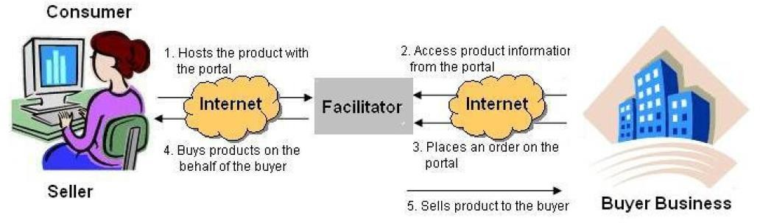

## C2B Business Model

Let us look at another example of the C2B model. William Ward needs to buy an airline ticket for his journey from New York to New Jersey. William needs to travel immediately. Therefore, he searches a Web site for a ticket. The Web site offers bidding facility to people who want to buy tickets immediately. On the Web site, William quotes the highest price and gets the ticket.

### Usage of C2B E-Commerce Model

1. **Freelance Services:**
   * Platforms like Upwork, Fiverr, and Freelancer allow individuals to offer services such as writing, graphic design, programming, and consulting to businesses.
2. **Content Creation:**
   * Bloggers, influencers, and content creators provide businesses with digital content (e.g., blog posts, videos, social media promotion) in exchange for payment or other benefits.
3. **Online Marketplaces for Creative Works:**
   * Sites like 99designs and Shutterstock enable consumers to sell original artwork, photography, or designs to businesses.
4. **Crowdsourcing and Crowdfunding:**
   * Platforms like Kickstarter or Indiegogo allow consumers to contribute ideas, feedback, or funding to business projects, often in exchange for rewards or early access to products.
5. **Review and Feedback Services:**
   * Some platforms offer consumers the opportunity to provide detailed reviews, surveys, or product testing services to businesses in exchange for compensation or discounts.
6. **Data Sharing:**
   * Consumers may share personal data or insights with businesses, often through loyalty programs or market research surveys, in exchange for rewards, discounts, or personalized services.
7. **Affiliate Marketing:**
   * Individuals create content (e.g., blogs, videos) promoting a company’s products, earning a commission for any sales generated through their referral links.
8. **Consumer Auctions:**
   * In some cases, consumers can auction off their services or products to the highest bidding business, reversing the typical auction model.

### Advantages of C2B E-Commerce Model

1. **Empowerment of Consumers:**
   * The C2B model empowers consumers by allowing them to set their own prices, terms, and conditions when offering products or services to businesses.
2. **Access to Niche Talent:**
   * Businesses can tap into a global pool of talent for specific, often niche, tasks or services that may not be available in-house.
3. **Cost-Effective Solutions:**
   * Hiring freelancers or buying consumer-generated content can be more cost-effective for businesses than employing full-time staff or developing content internally.
4. **Flexibility and Scalability:**
   * Businesses can easily scale their operations by engaging multiple freelancers or content creators as needed, without long-term commitments.
5. **Enhanced Consumer Engagement:**
   * By involving consumers directly in the creation of products, services, or marketing campaigns, businesses can foster stronger engagement and loyalty.
6. **Crowdsourced Innovation:**
   * Businesses can leverage the creativity and innovation of a large number of individuals, gaining fresh perspectives and ideas that might not emerge internally.
7. **Improved Market Understanding:**
   * Through consumer feedback, reviews, and data-sharing, businesses can gain a deeper understanding of their target market, leading to better products and services.
8. **Rapid Response to Market Needs:**
   * The C2B model allows businesses to respond quickly to market trends and demands by outsourcing work to freelancers or sourcing content from consumers.

### Disadvantages of C2B E-Commerce Model

1. **Quality Control Issues:**
   * Ensuring consistent quality in products, services, or content provided by a diverse group of consumers can be challenging for businesses.
2. **Security and Privacy Concerns:**
   * Handling sensitive data from consumers, especially when dealing with personal information or creative work, requires robust security measures and clear privacy policies.
3. **Dependence on External Providers:**
   * Relying heavily on freelancers or consumer-generated content can create dependency issues, particularly if key contributors are unavailable or unreliable.
4. **Intellectual Property Challenges:**
   * Businesses may face legal issues related to intellectual property rights when using content, designs, or ideas sourced from consumers.
5. **Potential for Exploitation:**
   * There is a risk of consumers being underpaid or exploited, particularly on platforms where competition drives down prices for services or content.
6. **Variable Engagement Levels:**
   * Not all consumers may be equally motivated or engaged, leading to inconsistency in the quality or quantity of contributions to a business.
7. **Management Complexity:**
   * Coordinating and managing a large number of individual contributors can be complex and time-consuming, especially when dealing with multiple freelancers or content creators.
8. **Market Saturation:**
   * As more businesses adopt the C2B model, competition for high-quality consumer contributions can increase, making it harder for businesses to stand out or secure top talent.

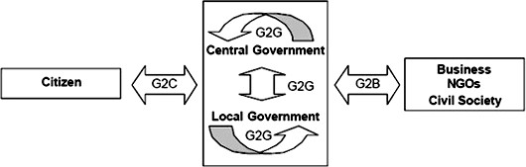In addition to the models discussed so far, five new models are being worked on that involves transactions between the government and other entities, such as consumer, business organizations, and other governments. All these transactions that involve government as one entity are called e-governance. The various models in the e-governance scenario are:

1. **Government-to-Government (G2G) model**: This model involves transactions between 2 governments. For example, if the American government wants to by oil from the Arabian government, the transaction involved are categorized in the G2G model.
2. **Government-to-Consumer (G2C) model**: In this model, the government transacts with an individual consumer. For example, a government can enforce laws pertaining to tax payments on individual consumers over the Internet by using the G2C model.
3. **Consumer-to-Government (C2G) model**: In this model, an individual consumer interacts with the government. For example, a consumer can pay his income tax or house tax online. The transactions involved in this case are C2G transactions.
4. **Government-to-Business (G2B) model**: This model involves transactions between a government and business organizations. For example, the government plans to build a fly over. For this, the government requests for tenders from various contractors. Government can do this over the Internet by using the G2B model.
5. **Business-to-Government (B2G) model**: In this model, the business houses transact with the government over the Internet. For example, similar to an individual consumer, business houses can also pay their taxes on the Internet.